**Features of Python programming**

**Features of any Programming language are nothing but Services (or) Facilities provided by language developers in languages and they are used by Language Programmer and they are used in Real Time Aipplications**

**=>Python Programming Provides 11 features. They are**

**================================================================**

**1) Simple**

**2) Freeware and Open Source**

**3) Platform Independent and Portable**

**4) Dynamically Typed**

**5) Interpreted**

**6) High Level**

**7) Robust (Strong)**

**8) Both Functional and Object oriented Programming**

**9) Extensible**

**10) Embedded**

**11) Supports Third Party APIs—Numpy,Pandas,Scipy , Scikit,matplotlib..etc**

**================================================================**

1. **Simple :=**

**=========================================**

**=> Python is one of the simple Programming language bcoz of 3 Important Tech Factors. They are:**

**-------------------------------------------------------------------------------------------**

**I) Python Programming Provides "Rich Set of APIs ". So that Python Programmer can re-use the pre-defined code without writing our own code.**

**--------------------------------------------------------------------------------------------**

**Def. of API (Application Programming Interface):**

**========================================================**

**=>An API is collection of Modules. A Module is a collection of Functions, Variables and Classes.**

**Examples:---- cmath , math , calendar, random...etc**

**========================================================**

**II) Python Programming Provides In-built Facility called "Garbage Collector. So that It It can run behind of every python program for Collecting Un-used memory and improves of Permance of Python Based Applications.**

**========================================================**

**Def. of Garbage Collector:**

**========================================================**

**=>A Garbage Collector is one of the Python Background Program, which is running behind of Every Regular Python Program and whose role is to collect un-used memory space and improces the performance of Python Based Application .**

**========================================================**

**Ill) Python programming Provides User-Friendly Syntaxes. So that Python Programmer can develop error-free program in limited span of time**.

**=====================================**

**Freeware and Open Source**

**============================================**

**Freeware:-**

**--------------------------------------------------------------------------------------------**

**=>Slnce python Programming is Freely downloadable and hence it is considered as**

**--------------------------------------------------------------------------------------------**

**-------------------------------------------------------------Open Source:**

**--------------------------------------------------------------------------------------------=>Once we we download Python Software, whose standard name given by Python 12 =>Many vendors came forward and then they customized the-CPYTHON" for devel opment**

**--------------------------------------------------------------------------------------------**

* **JYTHON (or) JPYTHON--->Used for running Java Based Applications**
* **Iron Python (or) (PYTHON-->Used for running C#.Net Applications**
* **Micro Pythpn--->Used To develop Micro Controller Applications.**
* **Ruby Pythbn—>Used to run Ruby Based Applications**
* **Anakonda Python-->Used to run EligData I Hadoop Based Applications. …….etc**

-------------------------------------------------------------------------------------------

**3)interpreted:-**

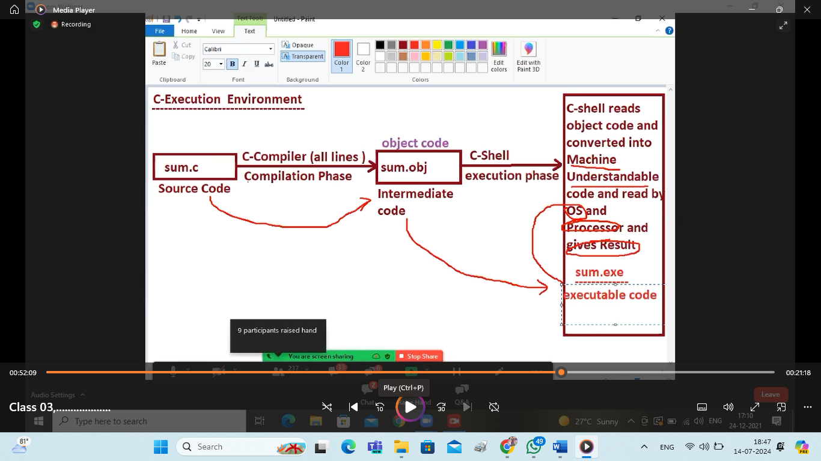 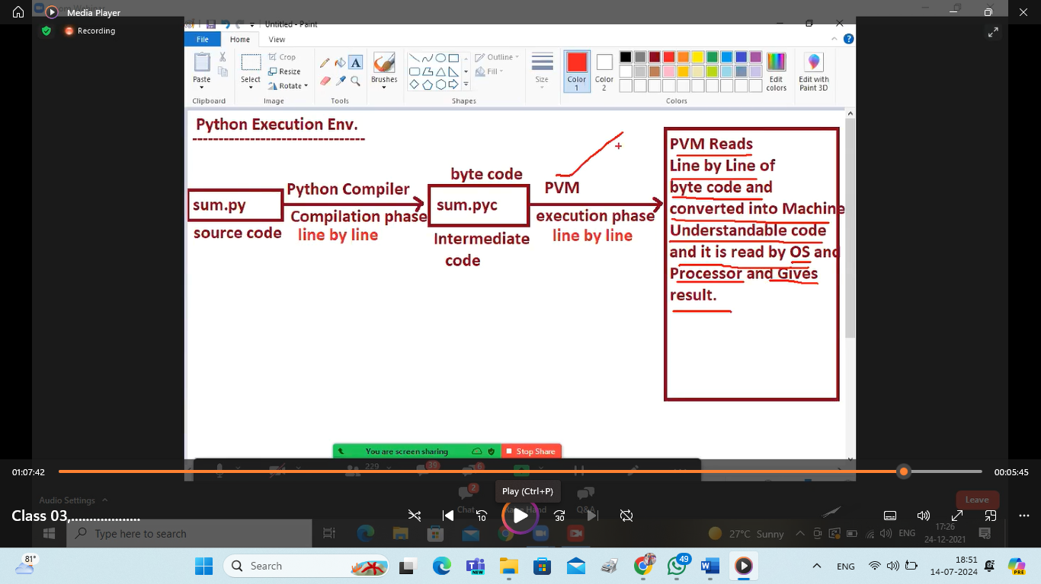 ------------------------------------------------------------------------------------------------------------------------------------**4)Platform Independent and Portable**

**-------------------------------------------------------------**

**=>Platform---->Type of OS being Used to run the application Program**

**-------------------------------------------------------------------------------------------**

**"'Property of Platform Independent in Python :**

**----------------------------------------------------------------------------------------- "All values are stored in the form of OBJECT and OBJECT does not contain size restrictions and they can store Un-Limited amount of Data and They are Indepenedent to all Types of OSes".**

**Examples:**

**========================================================**

**=>C,Cpp---etc are treated as Platform Dependent Lang--bcoz all the data types of C,CPP lang memory space is Varying the memory space from OS to another OS.**

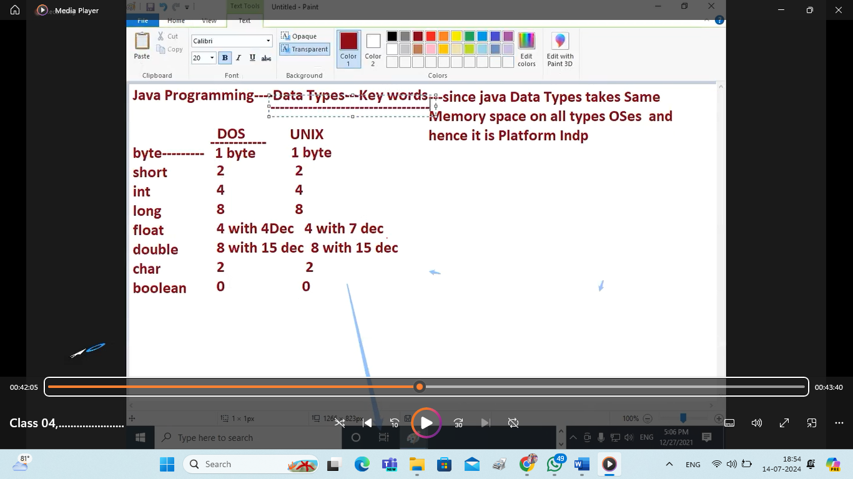

**========================================================**

**=> Java Program----PlatForm Independent Lang---- bcoz all the data types of java lang memory space is same the memory space from OS to another OS.**

**=======================================================**

**=> Python---- PlatForm Independent Lang-- bcoz all the data types of python lang memory space is same the memory space from OS to another OS.**

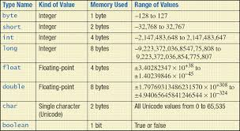

**========================================================**

**5)Dynamically typed:=**

**========================================================**

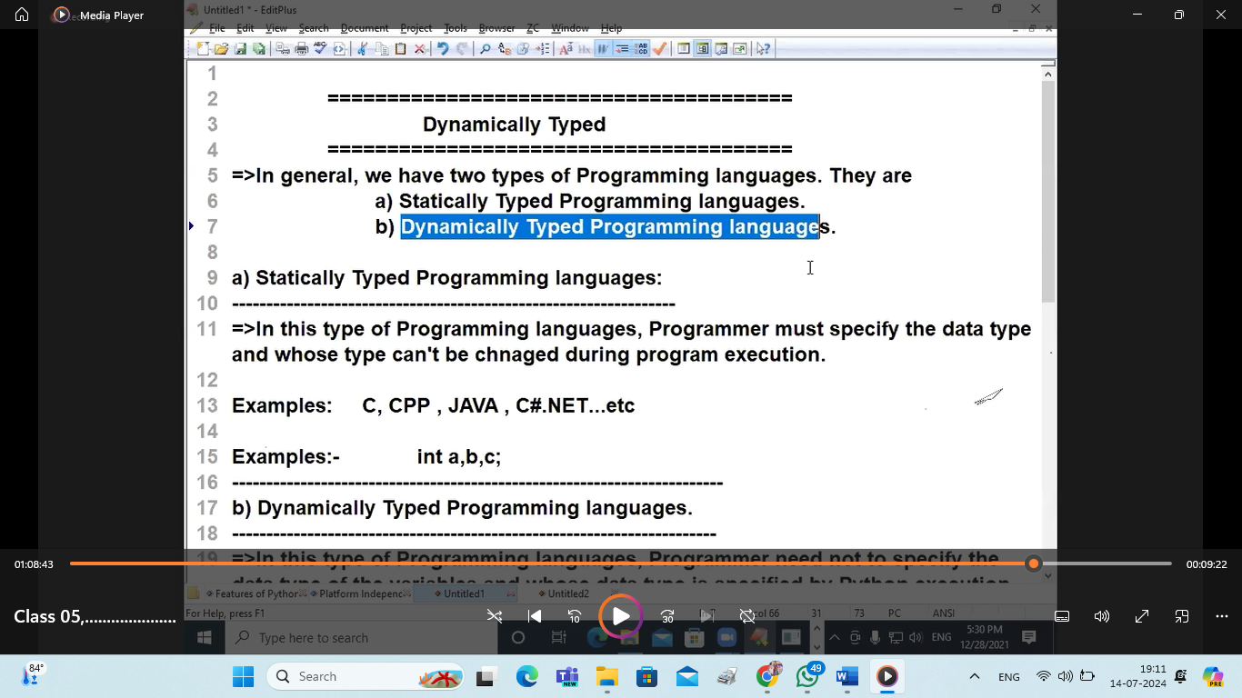

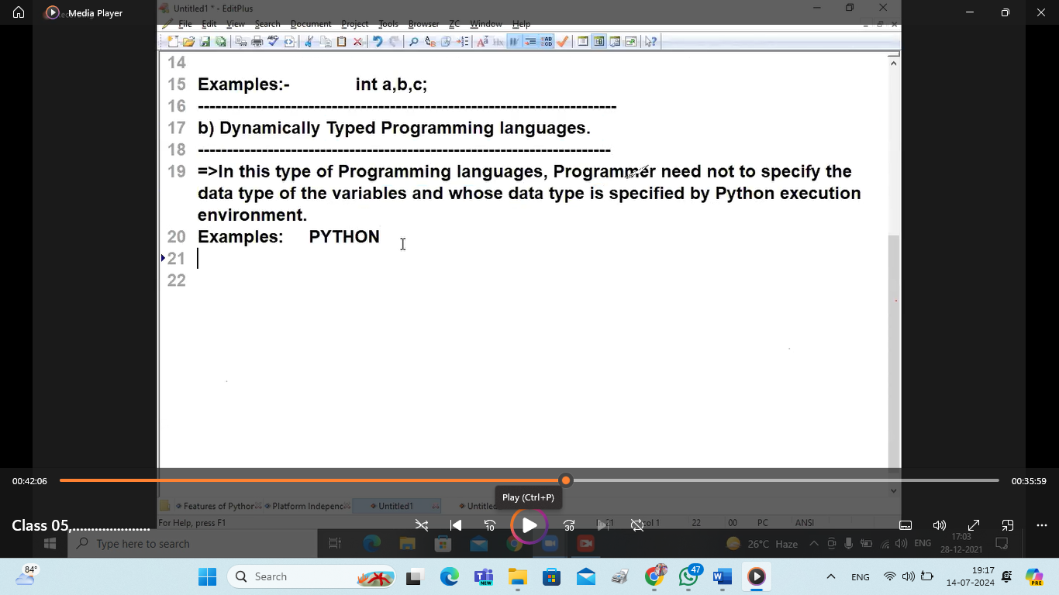

**High Level:=**

**======================================================== =>in this we have two types of programming languages. They are 2**

**a) Low Level Programming Lang**

**b) High Level Programming Lang**

**========================================================**

**=>Python Programming is High Level lang can convert Low Level Representation of Data into High level Data .ie Programmer / User Understandable Format.**

**Robust(strong):-**

* **Python is robust lang becoz it provides “Exception handling”.**
* **So it develop strong applications.**

**========================================================Extensible and Embedded :-**

**========================================**

**=>Python Programming provides a Facility to call it Libraries in other languages and Hence it is Extensible.**

**=>Python Programming can also embedded(Integrated) other language Code also and hence it is Embedded.**